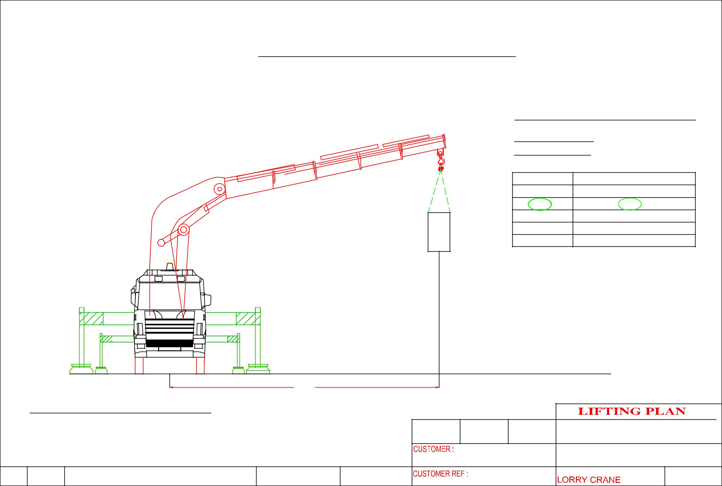
 |  |  | HOISTING OF MACHINE AT 1st FLOOR
 |  |  |  |  |  |  |  | CRANE :PALFINGER PK100002F
 |  |  |  |  |  |  |  | LORRY CRANE
 |  |  |  |  |  |  |  | CRANE CONFIGURATI0N
 |  |  |  |  |  | m6 |  | OPERATING RADIUS : 5.6m
 |  |  |  |  |  |  |  | ^{OPT . RADIUS(m)} |  | LIFTING CAPACITY OF CRANE IN KG
 |  |  |  |  |  |  |  | 4.4 |  |  | 18,800
 |  |  |  |  |  |  |  | 5.6 |  |  | 14,530
 |  |  |  |  |  |  |  | 7.4 |  |  | 10,960
 |  |  |  |  |  |  |  | 9.2 |  |  | 8,630
 |  |  |  |  |  |  |  | 11.1 |  |  | 7,020
 |  |  |  |  | MACHINE WEIGHT: | 8,000 KG |  | SAFETY FACTOR CALCULATION
 |  |  |  |  |  |  |  | WEIGHT OF CARGO |  |  | : 8,000 KG
 |  |  |  |  |  |  |  | LIFTING ACCESSORIES WEIGHT : 50 KG
 |  |  |  |  |  |  |  | TOTAL WEIGHT OF LIFTING |  |  | : 8,050 KG
 |  |  |  |  |  |  |  | LIFTING CAPACITY |  |  | :14,530 KG
 |  |  |  |  |  |  |  | SAFETY FACTOR |  |  | : 1,800 KG
 |  |  |  | 5.6M
 | CRANE :PALFINGER PK100002F
 |  |  |  |  |  | DRAWN | APPROVED | DATE | ERIC WONG MACHINERY TRANSPORTATION P/L
 |  |  |  |  |  |  | Cyrus Technology Singapore |  | DRAWING NAME:
 |  |  |  |  |  |  |  |  | HOISTING OF MACHINE

